1. **Agenda:**
   1. We are going to answer several questions as follows.
      1. What is Root Certificate Authority?
      2. How do Root Certificate Authority’s certificate look like?
      3. How do Browser trust Root Certificate Authority?
3. 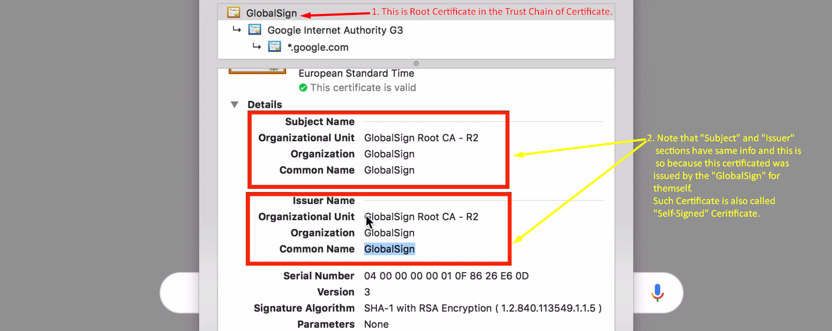
4.   
   This is self-signed certificate and you can create your own self-signed certificate and we will do it later on.   
   But any self-signed certificate can not be trusted. But this is being trusted in the trust chain.
5. 
6. Browser and Oss trust those Certificate Authorities and their certificates.
7. Answer: All Oss are shipped with the list of certificates of Root CA.
   1. That is why Web-Browser trusts these self-signed certificates.
   2. 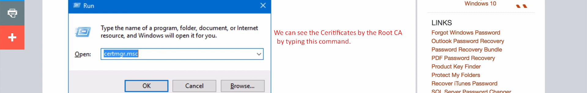
8. 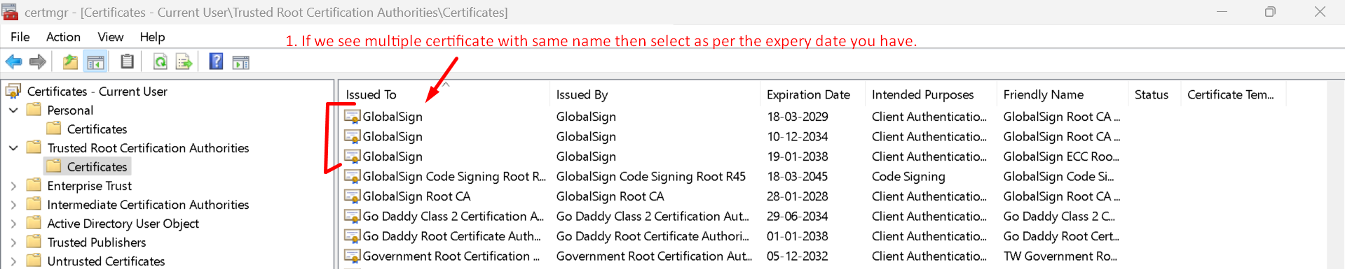
9. 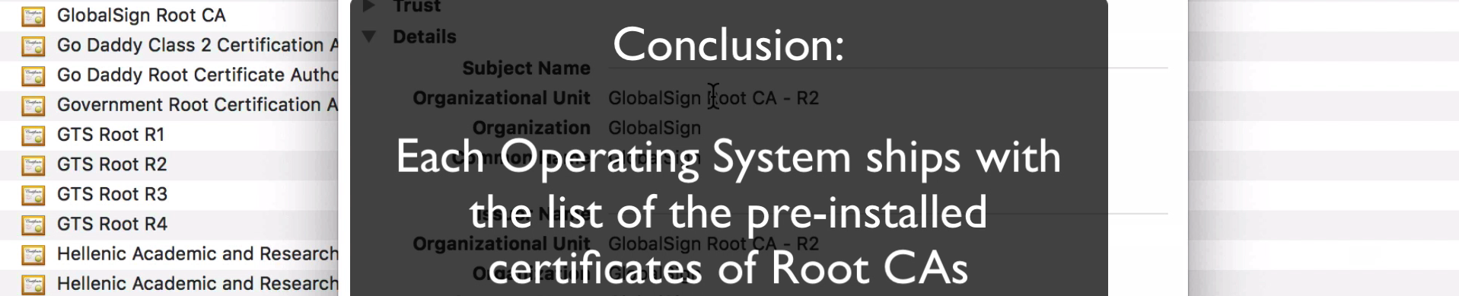
10. **NOTE**: Above we saw self-signed certificates issued by the Root CA for themselves.
11. You can also match the serial number from the browser’s view and that pre-installed in windows.
12. 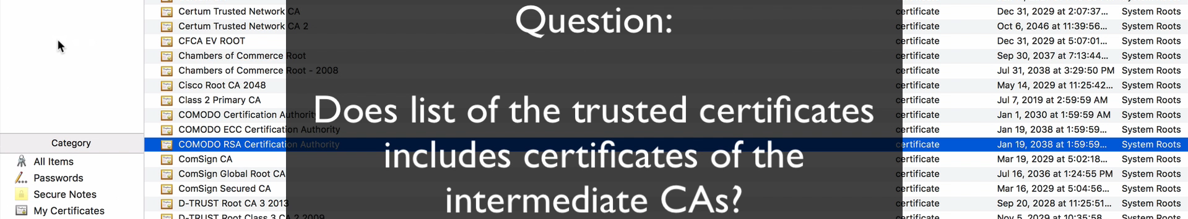
13. Answer: No. Only Root CA’s certificates are installed in OS.   
    **If** there is trust b/w Root CA and OS and there is trust b/w Root CA and Intermediate CA,   
    **Then** there is trust b/w Intermediate CA and OS.
14. 